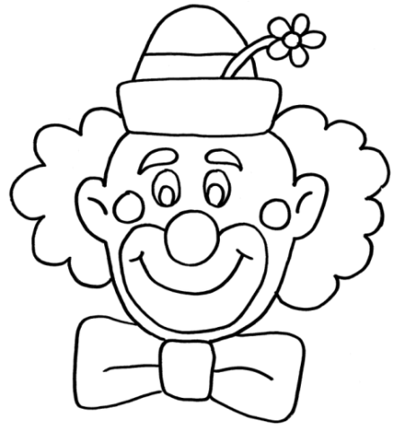
Meno: ____________________________________________ Body: ____________

1. Vyfarbi klauna podľa zadania.
hair - yellow nose - red
eyes – blue face – pink
ears – orange hat – green
6 b
2. Spoj obrázok so slovom.
kitchen living room bathroom bedroom 4 b
3. Doplň do viet predložky: in, on, under, podľa obrázka.
1. The teddy is .............. the bed. 2. The car is ...................... the bed.
3. The computer is ............... the desk. 4. The boat is .............. the box.
5. The boy is .............. the bed. 6. The train is ................. the chair. 6 b
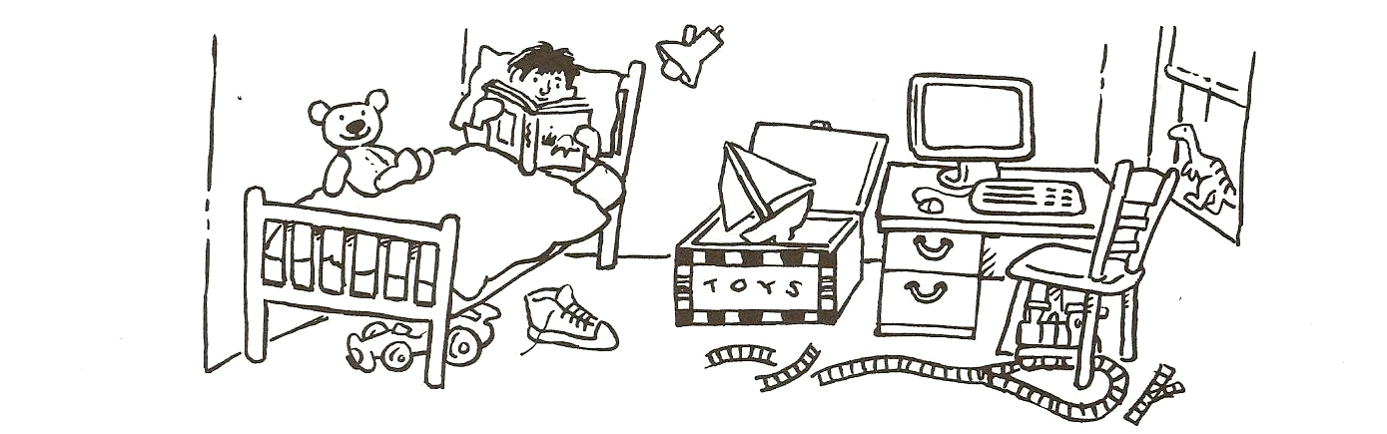
4. Koľko je na obrázku hviezdičiek? Zakrúžkuj správne slovo.

seven / six eight / two five / three four / one 4 b

5. Napíš správne pomenovanie členov rodiny.
t h e r b r o ____________________ d n g r a m a ______________________
u m m _______________________ t e r s s i __________________________
a d d _____________________ c l e n u ___________________________ 6 b

6. Dopíš odpoveď na základe obrázka.
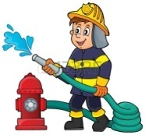 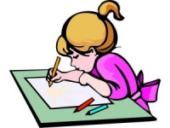 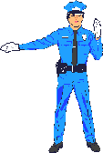 4 b
4
3
2
1

1. Is he a pilot? ____________________________________
2. Is he a doctor? _____________________________________
3. Is she a pupil? ______________________________________
4. Is he a policeman? ___________________________________
7. Usporiadaj slová vo vete správne a vety napíš.
a) I like don´t rice. ______________________________________________
b) Do milk? you like ______________________________________________
c) do What like? you ______________________________________________
d) like yogurt. I ____________________________________________________
e) don´t I grapes. like _____________________________________________ 5 b
8. Napíš, ktoré zvieratko je na obrázku.
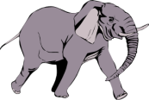_____________________________ 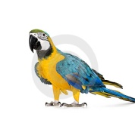________________________
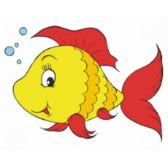__________________________ 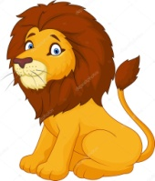 _________________________ 4 b

