HUV 7.C 20.1.2021

Počúvanie a nácvik piesne - IŠEU MACEK

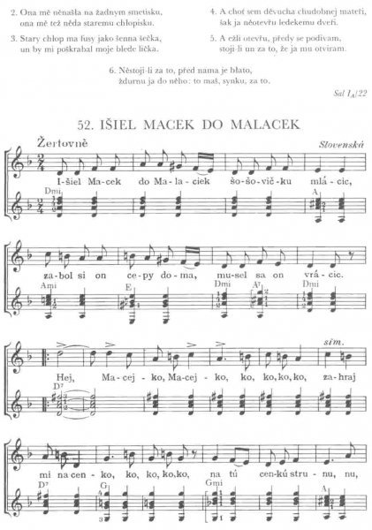

https://www.youtube.com/watch?v=CzUOfBmqdsw&ab_channel=Reletive

