TEST – was/werE
- Doplň was alebo were

- I .................. in the garden.
- You ......................... at home.
- They .................... in the classrom.
- .............................. we on the trip?
- My parents ........................... at a wedding.
- Peter ........................... at a theme park.

- VYTVOR VETY O OBRÁZKOCH
She was in the garden.
....................... ....................... hungry?

...................... ..................... in the park.
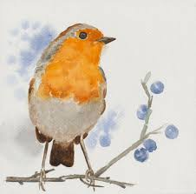
............................ ..................... very funny.
- Oprav chyby

He were ill. .......................................................................................
My sisters was at home. .....................................................................
Were she at school yesterday? ...........................................................
Were IT in the basket? ......................................................................

- Prelož vety do angličtiny
- Bol som šťastný....................................................................................
- My sme neboli v škole.........................................................................
- To bolo zábavné...................................................................................
- Peter nebol v kuchyni..........................................................................
- Bola mama v práci? ...........................................................................
- mačka nebola na pláži.........................................................................
- Boli oni zábavní? .................................................................................

- VYTVOR SPRáVNE DVOJICE. SPOJ VETU V ANGLIČTINE S JEJ PREKLADOM

- Where were you? A) Prečo bol tvoj brat tu?
- When was she at school? B) Kto bol tamten chlapec?
- Why was your brother here? C) Kde si bol?
- Who was that boy? D) Kedy bola ona v škole?

